

**Artificial Intelligence and Data Science Department.**

MP / Even Sem 2021-22 / Experiment 1.

YASH SARANG.

47 / D6AD.

EXPERIMENT - 1.

**____________________________________________________________**

**AIM:** Use of programming tool (TASM) to perform basic arithmetic operations on 8-bit/16-bit data.

(Addition and Subtraction is implemented here)

**____________________________________________________________**

**THEORY:**

EQUIPMENT REQUIRED:

1. TASM Software

2. PC with DOS and Debug program

ALGORITHM:

1. Define the values in the data segment as per the addressing mode.

2. Initialize the data segment register with data segment address

3. Load the words as per the addressing mode and perform addition/ subtraction/ multiplication/ division and store the sum/ difference/ product/

quotient-remainder to the result address.

4. Terminate the program

Flow Chart:

Addition, subtraction respectively :

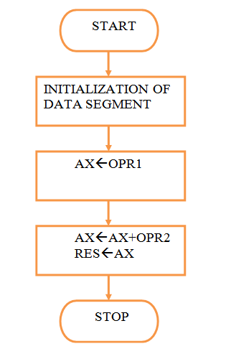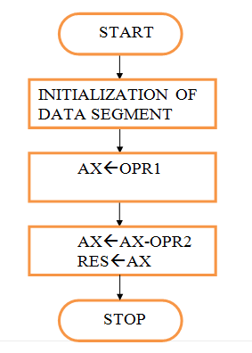

**____________________________________________________________**

**PROGRAMS** (using register addressing mode):

A. 16 BIT ADDITION

1 assume cs:code,ds:data

2

3 0000 data segment

4 0000 1243 n1 dw 1243h

5 0002 4567 n2 dw 4567h

6 0004 ???? n3 dw ?

7 0006 data ends

8

9 0000 code segment

10

11 0000 start:

12 0000 B8 0000s mov ax,data

13 0003 8E D8 mov ds,ax

14

15 0005 A1 0000r mov ax,n1

16 0008 8B 1E 0002r mov bx,n2

17 000C 03 C3 add ax,bx

18 000E A3 0004r mov n3,ax

19 0011 BE 0004r lea si,n3

20 0014 CC int 3

21

22 0015 code ends

23 end start

B. 16 BIT SUBTRACTION

1 assume cs:code,ds:data

2

3 0000 data segment

4 0000 FFFF n1 dw 0ffffh

5 0002 4567 n2 dw 4567h

6 0004 ???? n3 dw ?

7 0006 data ends

8

9 0000 code segment

10

11 0000 start:

12 0000 B8 0000s mov ax,data

13 0003 8E D8 mov ds,ax

14

15 0005 A1 0000r mov ax,n1

16 0008 8B 1E 0002r mov bx,n2

17 000C 2B C3 sub ax,bx

18 000E A3 0004r mov n3,ax

19 0011 BE 0004r lea si,n3

20 0014 CC int 3

21

22 0015 code ends

23 end start

**____________________________________________________________**

**RESULT:**

A. 16 BIT ADDITION

AX= 57AA & SI=0004 ; D 0004 0005 AA 57

B. 16 BIT SUBTRACTION

AX= BA98 & SI=0004 ; D 0004 0005 98 BA

**____________________________________________________________**